🧠 VDS AI Tooling

# VDS AI Tooling

The Verizon Design System (VDS) supports hundreds of designers, about two thousand developers, and hundreds of projects and teams across the company.

Effectively managing it at our scale is hard: tracking usage of the system, assessing our design and development community’s needs, not to mention developing design tokens and component libraries that work for all of those teams across several platforms—everything at our scale is hard.

This 86-day initiative has a singular goal: Make the VDS team’s work easier. We’ll accomplish that goal by providing the team with a bespoke suite of tools across three core pillars: Observatory, Foundry, Testbench.

Observatory (seeing stuff)
A big part of design system work is figuring out what downstream product teams are doing and where they’re going, as well as identifying where we can intervene and estimating the impact (positive and negative) with any intervention.

This facet of work can be challenging because, unlike with a website or app, design systems exist across many platforms that design system teams don’t own, which means observability of user behavior with our design system cannot be taken for granted.

It’s a bit easier at smaller companies with simpler org structures, but quite challenging at a company that’s #30 on the Fortune 500 list, employs about ~100,000 people, has multiple design and development departments, and lacks strong centralized DesignOps or DevOps.

Listen, we’re basically playing Battleship, but now we want to cheat and see the other person’s setup, and the Observatory tool suite will help us observe downstream designer and developer behavior.

What of the design system are they using, what are they building that we don’t offer, what are they building that we do offer, what are they struggling with, and what impact will we have if we make any change to the design system.

- Adoption Quality Dashboard will show where VDS is being used across the ecosystem, how much it’s being used, and how well.
- Demand Radar will periodically scan Verizon’s Figma workspace to identify and quantify unmet demand and VDS component drift.
- Breaking Change shows us the impact of any proposed change to the design system, before we ship.

Foundry (building stuff)
The VDS team—over 20 designers and developers—builds several types of digital assets for downstream designers and developers, including styles, variables, and components organized within Figma libraries, as well as design tokens, stylesheets, and components organized in Gitlab code repositories while distributed through Artifactory.

Recently, our team spent over a year building out a new version of the design system, based on Verizon’s rebrand launched 16 months prior.

The Foundry tool suite will accelerate clean and consistent creation of design system assets.

It will automate component specs and translate libraries across platforms, resulting in quality building blocks that are always aligned to VDS standards, faster.

- Component Specs
- Library Translator
- Writing Assistant

Testbench (testing stuff)
Proves every component is production-ready before release. It runs visual regression checks, tests variants across breakpoints, and simulates accessibility in real-world conditions. This safeguards speed-to-market by ensuring quality, parity, and inclusivity at scale.

- Component VQA
- Component Variant Testing

Adoption Quality Dashboard
#Observatory
Product Lead: Zukile Temba (Zuki) Ndulo
Engineering Lead: Rishita Gadde
The VDS Adoption Quality Dashboard will be a strategic tool to measure the true health and impact VDS. Currently, we lack visibility into how our system is being used, making it impossible to differentiate between healthy, consistent adoption and low-quality usage that creates tech debt and brand fragmentation. This dashboard moves beyond simple consumption metrics to introduce the concept of Adoption Quality, analogous to the business concept, "Quality of Sale." It's not enough to know that a team is using VDS; we need to know how much and how well they are using it.
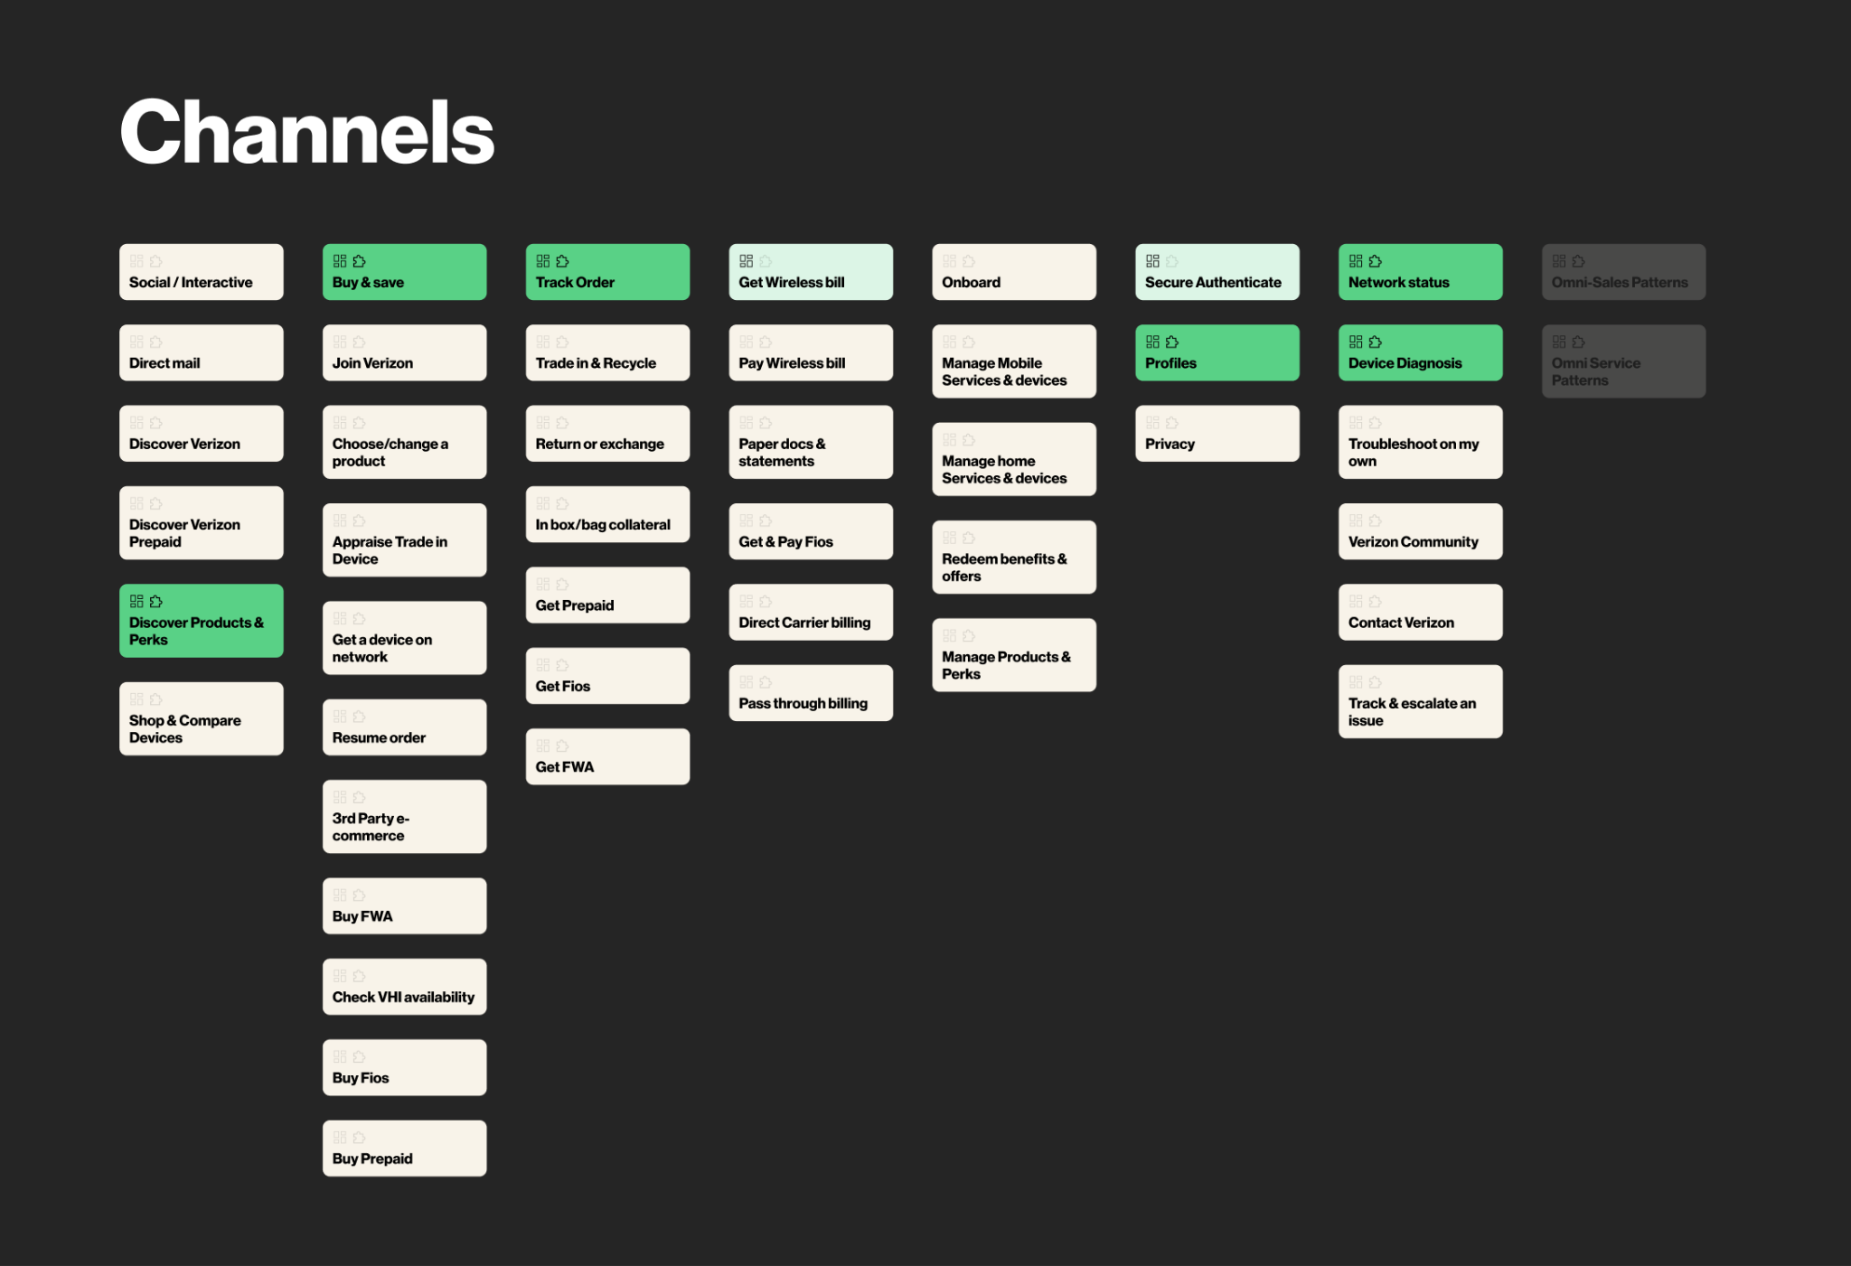
Design explorations by Gaurav Joshi and Premi Jovitta X
The purpose is to provide VDS leadership and the broader design organization with a single source of truth for system health, with all data aligned to the official VCG CX Design Organization Taxonomy. This will enable data-driven decision-making, drive accountability, and ensure we are delivering on the core promise of the design system: creating a more consistent, high-quality user experience across all of Verizon's digital properties.

Problem Statement
We are effectively blind to the true quality of VDS adoption across the organization. Without a system to measure adoption fidelity and cohesion, we cannot identify teams that are creating brand inconsistencies and tech debt by overriding components, nor can we strategically invest our resources to improve the system's effectiveness, ultimately failing to prove the ROI of VDS.

Current State
Our current understanding of VDS adoption is limited to basic, often manual, consumption counts. We might know that a team is a "VDS adopter," but we have no quantitative data on the depth or quality of that usage. We cannot answer critical questions like:
- Are teams using components as designed, or are they overriding them?
- Do the implemented components in production actually match the designs in Figma?
- Which parts of the VCG CX Design Organization are excelling in adoption, and which are lagging?
This lack of insight means we operate on assumptions, making it impossible to manage the design system as a strategic asset.

Outcomes
The primary success metric will be the Adoption Quality Score, a composite metric calculated from:
- Breadth Score: Teams using VDS, even a little.
- Depth Score: The degree to which teams are utilizing VDS.
- Fidelity Score: The percentage of VDS component instances used without overrides or customizations.
- Cohesion Score: The percentage of component instances in production that visually and structurally match their corresponding designs in Figma.
A web-based dashboard that visualizes VDS adoption through the lens of the Adoption Quality Model. The dashboard will provide a comprehensive view of who is using VDS, how much they are using it, and—most importantly—how well they are using it.

Functional Requirements
- Data Integration
  - Ingest component and token usage data from Figma to establish a baseline for design intent.
  - Ingest component and token usage data from GitLab to understand production implementation.
- Adoption Quality Analysis
  - The system must automatically scan code to detect component overrides, restyling, and customizations to calculate a Fidelity Score.
  - The system must perform automated comparisons between Figma assets and production code/screenshots to calculate a Cohesion Score.
  - The system must calculate an overall Adoption Quality Score based on Fidelity and Cohesion.
- Dashboard & Visualization
  - Display the Adoption Quality Score, along with metrics for adoption breadth (who) and depth (how much).
- Dynamic
  - VCG CX Design Organization Taxonomy-centricity; users must be able to drill down into specific areas, such as:
    - Experience Ecosystems
    - Customer Intents (e.g., Buy, Pay, Manage Account)
    - Products (e.g., Digital Sales, Digital Service)
    - Digital and Assisted Touchpoints
- User Interface
  - A clean, intuitive, web-based dashboard accessible to authorized VDS stakeholders and organizational leaders.

Non-Functional
- Accuracy: The detection of overrides (Fidelity) and design-to-dev mismatches (Cohesion) must be highly accurate to be trustworthy.
- Performance: The dashboard must load quickly, even with large datasets. Data ingestion and analysis can run as batch processes.
- Scalability: The system must be able to handle a growing number of Figma files, code repositories, and components.
- Security: Access to the dashboard will be role-based to ensure data is only visible to appropriate personnel.

Global Dependencies
- APIs: Stable and performant APIs for both Figma and GitLab are essential.
- Data Mapping: A robust and maintainable process for mapping thousands of Figma files and GitLab repos to the specific teams and products within the VCG CX Design Organization Taxonomy. This may require a service like Airtable or an internal ownership database.
- Analysis Engine: A sophisticated engine capable of static code analysis and potentially visual regression testing to calculate fidelity and cohesion scores.

Global Risks
- Feasibility Risk (Can we build it?): The riskiest assumption is that we can accurately and scalably automate the measurement of Fidelity and Cohesion. Detecting nuanced code overrides and reliably comparing a Figma design to a live component is a significant technical challenge.
- Viability Risk (Does this work for our business?): The riskiest assumption is that we can achieve the necessary organizational alignment to not only grant broad data access but also to act on the insights provided. The taxonomy mapping is a critical dependency that requires cross-team cooperation.
- Value Risk (Will anyone use it?): If the data is inaccurate or the scores are perceived as punitive rather than helpful, teams will ignore the dashboard. The insights must be presented in a way that empowers teams to improve, rather than punishing them for low scores.

Adoption Quality Model

Our Adoption Quality Model evaluates VDS adoption across three key dimensions:
- Who’s using it
- How much they’re using it
- How well they’re using it

1. Who is using VDS?
Are teams using VDS, yes or no?
We care both about design and development adoption, as design is often a leading indicator of dev usage.
But, ultimately, we hold ourselves accountable to dev adoption.

2. How much are they using it?
After confirming a team is using VDS, we assess how extensively they use it. Are they utilizing our token packages, and if so, which ones? (e.g., Typography, Spacing, Color.) How many tokens and components from our core library are teams integrating, and which ones? This shifts our perspective from mere presence (yes/no) to depth of adoption, akin to assessing how extensively someone fills their shopping cart—not just if they entered the store.

Also consider:
- Percentage of a page that uses VDS
- How many are they using compared to what they could/should use

3. How well are they using it?
Here, quality of adoption is measured through three distinct categories:

Fidelity
Are teams using components exactly as designed, without overriding, restyling, customizing? Automated code-scans and visual audits ensure compliance; deviations undermine consistency and increase technical debt.

Cohesion
Do the design (Figma) and production (development) assets match precisely? We verify that components in Figma are identical to production implementations, ensuring alignment and minimizing errors during handoffs.

Google Workspace (Docs, Slides, Sheets), Atlassian (JIRA, Confluence), Slack, Figma, Gitlab. However, we do own and operate our documentation website: https://beta.designsystem.verizon.com.
Not because of their quality–they’re good. There just isn’t enough of them to be super influential.

